RCF REPORT, JUNE 2019
Please See Competition Film: https://www.youtube.com/watch?v=wmLIb9if-aM
‘SONG QUEEN: A PIDGIN OPERA’ THE WORLD’S FIRST PIDGIN ENGLISH OPERA COMES TO TOWN TO DAZZLE, ENGAGE AND INSPIRE.
EMC3 Nigeria in collaboration with Mike Adenuga Alliance Française Centre, Wazobia TV/Radio in aid of the Richard Coker Foundation presented ‘Song Queen: A Pidgin Opera’ the world’s first pidgin English opera, by The Venus Bushfires aka Helen Epega.
On the 26th, June 2019, students of three public secondary schools in Lagos got an initiation into the artistic world of the opera, courtesy of the Richard Coker Foundation (RCF) and The Venus Bushfires.
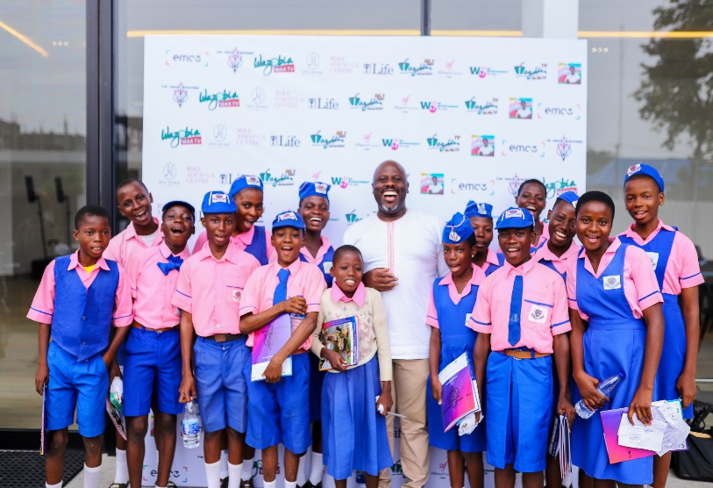
It was a typical late June day, buses conveying 100 students in year JSS3, teachers and parents from Immaculate Heart Junior Comprehensive High School, Maryland, Opebi Junior Grammar School, Opebi and Yewa Junior High School, Ikorodu to Mike Adenuga Alliance Francaise Centre, Ikoyi.
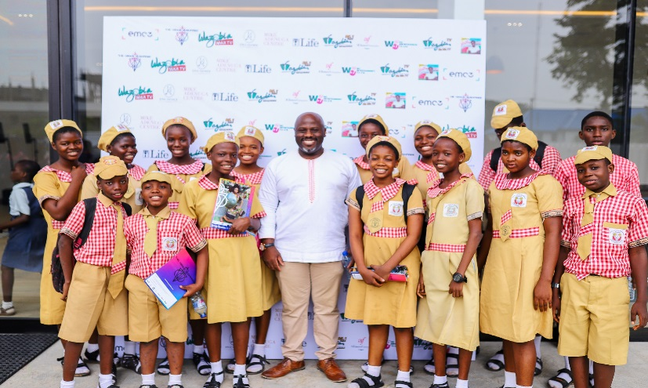

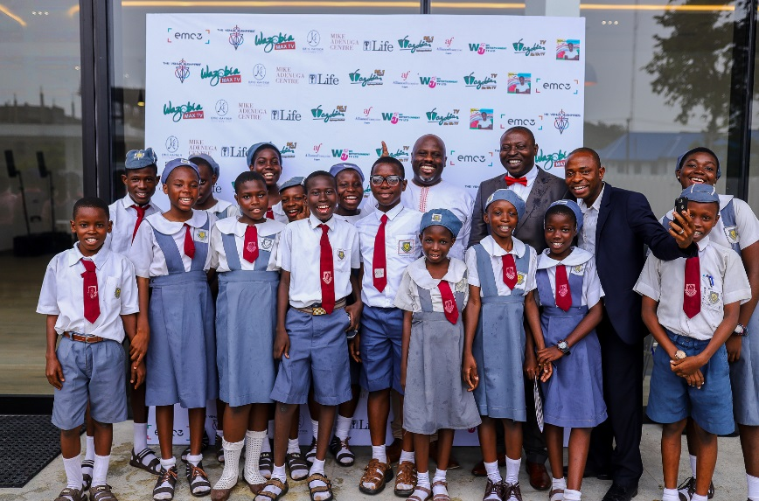
The schools were selected to take part in the pilot test of an annual SCD Essay Competition, an RCF vision to amplify sickle cell awareness among young Nigerians.
The inaugural topic was, ‘HOW LIVING WITH SICKLE CELL HAS INSPIRED ME OR SOMEONE I KNOW’. After a grueling assessment process, a winner was picked from each school by Helen Epega.
Few days before the main event, a visitation was made to Maryland Junior School with WazobiaTV/Radio to announce the winners and make some filming and interviews.
The day dawns with a twin set of events, the first of which is a matinee which was with the students, the students were well fed and given Song Queen brochures before they were been ushered into the theatre for the Opera show. The winners of the essay competition were announced and given there prizes alongside with their parents and teachers.

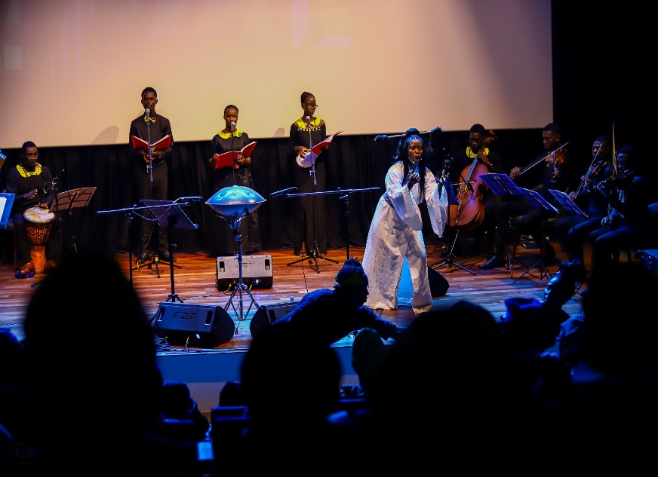

1st Prize – Adedayo Quadri, of Immaculate Heart Junior Comprehensive School (₦75,000)
2nd Prize – Bulama Fatima, of Opebi Grammar School (₦40,000)
3rd Prize – Rahmon Felix Oluwaseun, of Yewa Junior High School (₦20,000)
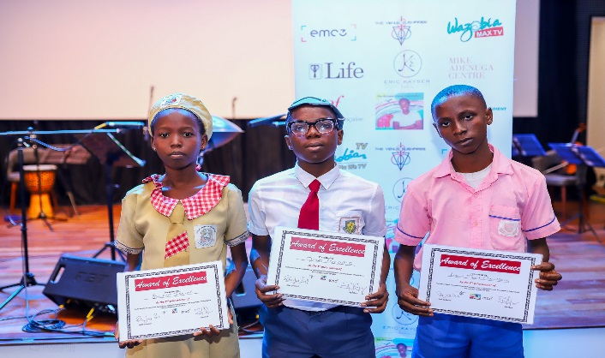
(Immaculate Heart, from which the winning essay emerged, had its sanitary facilities renovated to the tune of over ₦200,000).
Later in the evening was the second performance opened to the public.

This was first of its kind which we have planned to do every year in conjunction with the Sickle Cell News & World Report Magazine, to promote sickle cell awareness through reading, writing, sharing personal stories and reasoning among junior students in public schools in Nigeria.

“This opera is about celebrating that which brings Nigerians together and sharing African art and culture with ourselves and the world in an inclusive way”, says Song Queen’s composer Helen Epega.

